Full stack application development:

2 folders are there

1. Frontend – Code for UI content
2. Backend – Code for express and DB

Open new terminal🡪

Open Terminal 🡪

To start with backend, > cd backend

>npm start

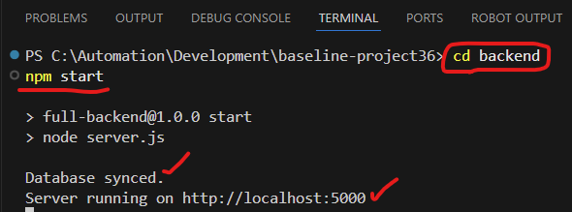

Open one more terminal 🡪

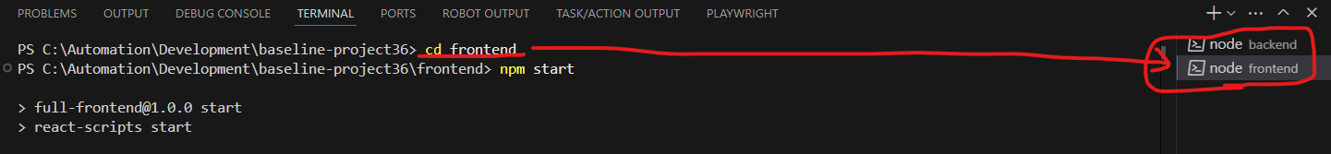

Whenever you want to work with backend or frontend, switch to the specific terminal by clicking on the above.

-sriram

-Trichy@123

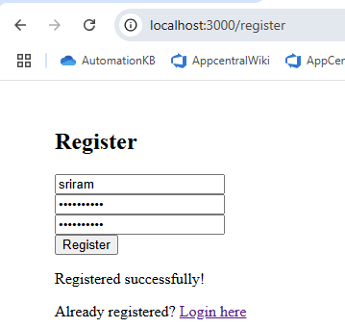

To verify if the data is saved successfully in the backend:

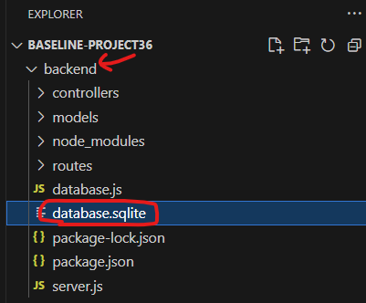

Go to backend 🡪database.sqlite 🡪 open this in “DB Browser (SQLite)”.

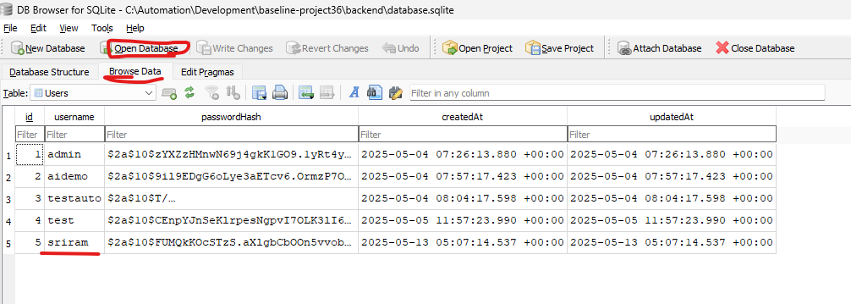

Open the desktop application 🡪 DB Browser for SQLite 🡪 Click on Open Database 🡪 click on Browse Data 🡪 Change the table to Users 🡪 Verify if the data is displayed in the Table. Newly registered details should display here.

Each backend and frontend folder will have the file – package.json.

**Package.json** holds the dependencies for the project.

To download the dependencies and associate with the project, use the command

🡪 **npm install** 🡪 this will download the dependencies into the folder **node_modules.**

To stop the server:

Control+C

To start the server:

>npm start

Username – AutoPro

Password – Admin@123